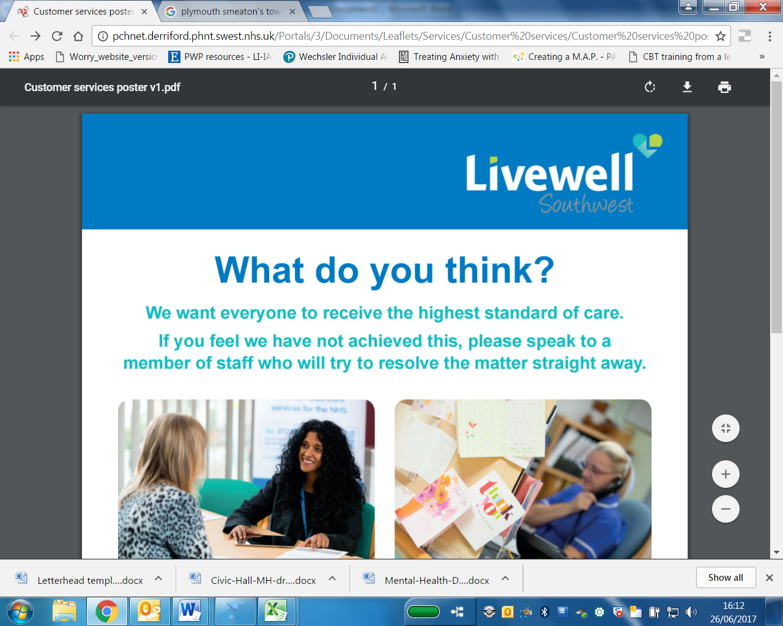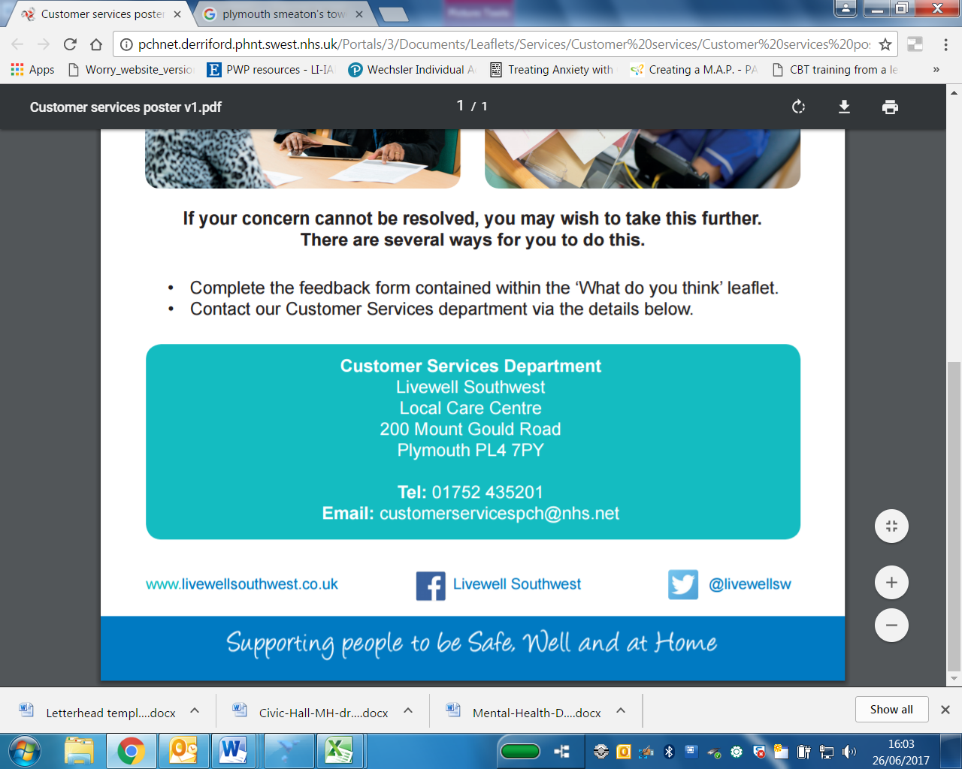

When? Friday 3rd August 10-12

Thursday 23rd August 2-4

Where? The Pig, Armada Way, PL1 1HU

If you’re worried about something that’s happening in your life, need some space to talk or want some advice on how you’re feeling, drop in and have a chat to a trained professional.

You can come on your own or with someone else; you will always be made to feel welcome.

**For children aged 5 to 18 and their families**

**Emotional Health and Wellbeing Drop In**

